Towers Activities Weekly Calendar

Sunday | Monday | Tuesday | Wednesday | Thursday | Friday | Saturday
26 | 27 | 28 | 29 | 30 | 31 | 1

10am Church Service- Heritage Hall  4:30pm Nederland’s Zingt – Ch.990  7pm Church Service – Heritage Hall  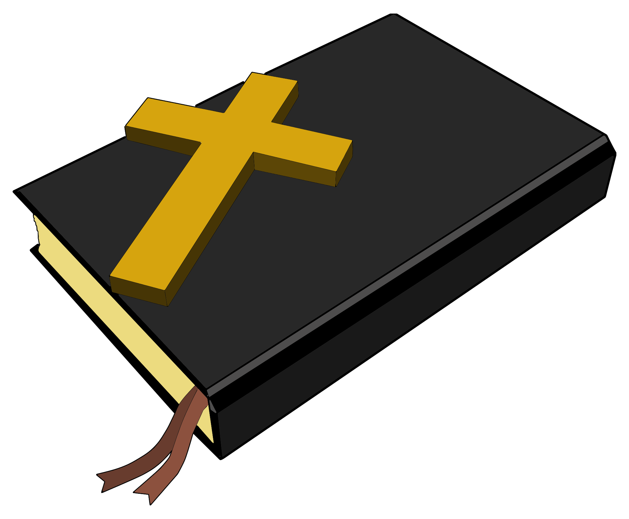  Index: TT = Trinity Tower  KT = King Tower  PT = Providence Tower  CT = Covenant Tower  HT = Hope Tower  PcT = Peace Tower  HeH = Heritage Hall  HaH = Harmony Hall  HoH = Horizon Hall  Italics = CH990  Underline = Towers Nursing Office | 10am Roman Catholic Mass – Harmony Hall  10:30am Peace Tower Coffee Social – Horizon Hall  2pm- Bingo! – Harmony Hall  7pm Sing Out! – Heritage Hall  Sign-Up Event  7pm Paint Night- Harmony Hall | 9:30am Devotions Ch.990  10am Hope & Trinity Coffee Social – Harmony Hall  11am Tune into Tunes “Toronto Sinfonia” – Ch. 990  11am Fun + Fitness - Heritage Hall  1pm Bridge Club – KT Library  2:30pm Covenant Tower Coffee Social- Covenant Tower Lounge  6:30pm Bid Euchre – PT Meeting Room | 8:30am Foot Care Clinic – TNO Nursing Station  9am Busy Hands – Trinity Tower Meeting Room  10am Chapel – Horizon Hall  1:30pm Cribbage Club – PT Meeting Room  1:30pm Art Expressions – Trinity Tower Meeting Room  2pm Operation Mercy Yarn Pick up – Harmony Hall  2pm Birthday Party - Entertainer “4 Heaven’s Sake” – Heritage Hall | 9:30am Devotions  Ch. 990  10am Tai Chi – Horizon Hall  1pm Klaverjassen – KT Library  2pm Prayer Shawl Group – CT Lounge  7pm KTEE Euchre – Horizon Hall | 11am Fun + Fitness - Heritage Hall  11am Yoga with Kathleen Osmond – Horizon Hall  1:30pm Karaoke – Harmony Hall  7pm Board Games Night – Horizon Hall  7pm Bingo! – Harmony Hall | 10am King Tower Coffee Social – Horizon Hall  10am – Providence Tower Coffee Social – PT Meeting Room
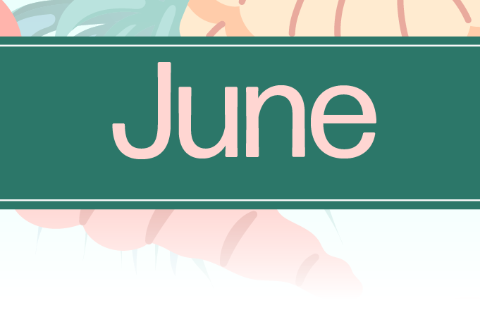
HCH Towers Activities
Sunday | Monday | Tuesday | Wednesday | Thursday | Friday | Saturday
2 | 3 | 4 | 5 | 6 | 7 | 8

Towers Activities Weekly Calendar

10am Church Service- Heritage Hall  4:30pm Nederland’s Zingt – Ch.990  7pm Church Service – Heritage Hall  Index: TT = Trinity Tower  KT = King Tower  PT = Providence Tower  CT = Covenant Tower  HT = Hope Tower  PcT = Peace Tower  HeH = Heritage Hall  HaH = Harmony Hall  HoH = Horizon Hall  Italics = CH990  Underline = Towers Nursing Office | 10am Roman Catholic Mass – Harmony Hall  10:30am Peace Tower Coffee Social – Horizon Hall  10:30am Cody’s Cows – Outside the old Faith Manor  2pm- Bingo! – Harmony Hall  7pm Sing Out! – Heritage Hall | 9:30am Devotions Ch.990  10am Hope & Trinity Coffee Social – Harmony Hall  11am Fun + Fitness - Heritage Hall  10am Music & Movement – Horizon Hall  1pm Bridge Club – KT Library  2:30pm Covenant Tower Coffee Social- Covenant Tower Lounge  6:30pm Bid Euchre – PT Meeting Room | 9am Busy Hands – Trinity Tower Meeting Room  10am Chapel – Horizon Hall  1:30pm Cribbage Club – PT Meeting Room  1:30pm Art Expressions – Trinity Tower Meeting Room  2pm Operation Mercy Yarn Pick up – Harmony Hall | 9:30am Devotions  Ch. 990  10am Vendor: Bijoux Treasures – Outside Horizon Hall  1pm Klaverjassen – KT Library  1:30pm Movie Matinee – Heritage Hall  2pm Prayer Shawl Group – CT Lounge  7pm KTEE Euchre – Horizon Hall | 11am Fun + Fitness - Heritage Hall  11am Yoga with Kathleen Osmond – Horizon Hall  2pm HCH Coffee Social – Harmony Hall  Come Meet Nakita  7pm Board Games Night – Horizon Hall  7pm Bingo! – Harmony Hall | 10am King Tower Coffee Social – Horizon Hall  10am – Providence Tower Coffee Social – PT Meeting Room
HCH Towers Activities.
Sunday | Monday | Tuesday | Wednesday | Thursday | Friday | Saturday
9 | 10 | 11 | 12 | 13 | 14 | 15

Towers Activities Weekly Calendar

10am Church Service- Heritage Hall  4:30pm Nederland’s Zingt – Ch.990  7pm Church Service – Heritage Hall  Index: TT = Trinity Tower  KT = King Tower  PT = Providence Tower  CT = Covenant Tower  HT = Hope Tower  PcT = Peace Tower  HeH = Heritage Hall  HaH = Harmony Hall  HoH = Horizon Hall  Italics = CH990  Underline = Towers Nursing Office | 10am Roman Catholic Mass – Harmony Hall  10:30am Peace Tower Coffee Social – Horizon Hall  11am Armchair Travels “Croatia: Adriatic Delights” – Ch. 990  2pm- Bingo! – Harmony Hall  7pm Sing Out! – Heritage Hall | 9:30am Devotions Ch.990  10am Vendor: Avon – Across from Front Reception  10am Hope & Trinity Coffee Social – Harmony Hall  11am Fun + Fitness - Heritage Hall  1pm Bridge Club – KT Library  2:30pm Covenant Tower Coffee Social- Covenant Tower Lounge  6:30pm Bid Euchre – PT Meeting Room  7pm Heartland Singers Performance – Heritage Hall | 9am Busy Hands – Trinity Tower Meeting Room  10am Chapel – Horizon Hall  1:30pm Cribbage Club – PT Meeting Room  1:30pm Art Expressions – Trinity Tower Meeting Room  2pm Operation Mercy Yarn Pick up – Harmony Hall | 9:30am Devotions  Ch. 990  10am Vendor: Traditions Alive – Outside Horizon Hall  1pm Klaverjassen – KT Library  2pm Prayer Shawl Group – CT Lounge  7pm KTEE Euchre – Horizon Hall | 11am Fun + Fitness - Heritage Hall  11am Yoga with Kathleen Osmond – Horizon Hall  7pm Board Games Night – Horizon Hall  7pm Bingo! – Harmony Hall | 10am King Tower Coffee Social – Horizon Hall  10am – Providence Tower Coffee Social – PT Meeting Room
HCH Towers Activities
Sunday | Monday | Tuesday | Wednesday | Thursday | Friday | Saturday
16 | 17 | 18 | 19 | 20 | 21 | 22

Towers Activities Weekly Calendar

10am Church Service- Heritage Hall  4:30pm Nederland’s Zingt – Ch.990  7pm Church Service – Heritage Hall  Index: TT = Trinity Tower  KT = King Tower  PT = Providence Tower  CT = Covenant Tower  HT = Hope Tower  PcT = Peace Tower  HeH = Heritage Hall  HaH = Harmony Hall  HoH = Horizon Hall  Italics = CH990  Underline = Towers Nursing Office | 10am Roman Catholic Mass – Harmony Hall  10:30am Peace Tower Coffee Social – Horizon Hall  2pm- Bingo! – Harmony Hall  7pm Sing Out! – Heritage Hall | 9:30am Devotions Ch.990  10am Hope & Trinity Coffee Social – Harmony Hall  10am Vendor: Nelly’s Comfort Shoes – Across from Front Reception  11am Fun + Fitness - Heritage Hall  10am Music & Movement – Horizon Hall  1pm Bridge Club – KT Library  2:30pm Covenant Tower Coffee Social- Covenant Tower Lounge  6:30pm Bid Euchre – PT Meeting Room | 9am Busy Hands – Trinity Tower Meeting Room  10am Chapel – Horizon Hall  1:30pm Cribbage Club – PT Meeting Room  1:30pm Art Expressions – Trinity Tower Meeting Room  2pm Operation Mercy Yarn Pick up – Harmony Hall  7:30pm Circle of Harmony Chorus Performance – Heritage Hall | 9:30am Devotions  Ch. 990  1pm Klaverjassen – KT Library  1:30pm Johnny Cash Tribute Concert – Town Square (CT Flag Poles)  2pm Prayer Shawl Group – CT Lounge  7pm KTEE Euchre – Horizon Hall  7pm Movie Night- Heritage Hall | 11am Fun + Fitness - Heritage Hall  7pm Board Games Night – Horizon Hall  7pm Bingo! – Harmony Hall | 10am King Tower Coffee Social – Horizon Hall  10am – Providence Tower Coffee Social – PT Meeting Room
HCH Towers Activities
Sunday | Monday | Tuesday | Wednesday | Thursday | Friday | Saturday
23 | 24 | 25 | 26 | 27 | 28 | 29

Towers Activities Weekly Calendar

10am Church Service- Heritage Hall  4:30pm Nederland’s Zingt – Ch.990  7pm Church Service – Heritage Hall  Index: TT = Trinity Tower  KT = King Tower  PT = Providence Tower  CT = Covenant Tower  HT = Hope Tower  PcT = Peace Tower  HeH = Heritage Hall  HaH = Harmony Hall  HoH = Horizon Hall  Italics = CH990  Underline = Towers Nursing Office | 10am Roman Catholic Mass – Harmony Hall  10:30am Peace Tower Coffee Social – Horizon Hall  11am Tune into Tunes “Toronto Sinfonia” – Ch. 990  2pm- Bingo! – Harmony Hall  7pm Sing Out! – Heritage Hall | 9:30am Devotions Ch.990  10am Vendor: Simply Pretty Jewelry – Across from Front Reception  10am Hope & Trinity Coffee Social – Harmony Hall  11am Fun + Fitness - Heritage Hall  1pm Bridge Club – KT Library  1:30pm Brynn Albanese Performance (Heritage Hall) + Meet & Greet Afterwards (Harmony Hall  2:30pm Covenant Tower Coffee Social- Covenant Tower Lounge  6:30pm Bid Euchre – PT Meeting Room | 9am Busy Hands – Trinity Tower Meeting Room  10am Chapel – Horizon Hall  1:30pm Cribbage Club – PT Meeting Room  1:30pm Art Expressions – Trinity Tower Meeting Room  2pm Talk & Teach “Sun Safety” -Harmony Hall  2pm Operation Mercy Yarn Pick up – Harmony Hall | 9:30am Devotions  Ch. 990  1pm Klaverjassen – KT Library  2pm Prayer Shawl Group – CT Lounge  7pm KTEE Euchre – Horizon Hall | 11am Fun + Fitness - Heritage Hall  11am Yoga with Kathleen Osmond – Horizon Hall  1:30pm Karaoke – Harmony Hall  7pm Board Games Night – Horizon Hall  7pm Bingo! – Harmony Hall | 10am King Tower Coffee Social – Horizon Hall  10am – Providence Tower Coffee Social – PT Meeting Room
HCH Towers Activities
Sunday Monday Tuesday Wednesday Thursday Friday Saturday  30 1 2 3 4 5 6 | Towers Activities Weekly Calendar
10am Church Service- Heritage Hall  4:30pm Nederland’s Zingt – Ch.990  7pm Church Service – Heritage Hall  Index: TT = Trinity Tower  KT = King Tower  PT = Providence Tower  CT = Covenant Tower  HT = Hope Tower  PcT = Peace Tower  HeH = Heritage Hall  HaH = Harmony Hall  HoH = Horizon Hall  Italics = CH990  Underline = Towers Nursing Office | 10am Roman Catholic Mass – Harmony Hall  10:30am Peace Tower Coffee Social – Horizon Hall  2pm- Bingo! – Harmony Hall  7pm Sing Out! – Heritage Hall | 9:30am Devotions Ch.990  10am Hope & Trinity Coffee Social – Harmony Hall  11am Fun + Fitness - Heritage Hall  1pm Bridge Club – KT Library  2:30pm Covenant Tower Coffee Social- Covenant Tower Lounge  6:30pm Bid Euchre – PT Meeting Room | 9am Busy Hands – Trinity Tower Meeting Room  10am Chapel – Horizon Hall  1:30pm Cribbage Club – PT Meeting Room  1:30pm Art Expressions – Trinity Tower Meeting Room  2pm Operation Mercy Yarn Pick up – Harmony Hall | 9:30am Devotions  Ch. 990  1pm Klaverjassen – KT Library  2pm Prayer Shawl Group – CT Lounge  7pm KTEE Euchre – Horizon Hall | 11am Fun + Fitness - Heritage Hall  11am Yoga with Kathleen Osmond – Horizon Hall  7pm Board Games Night – Horizon Hall  7pm Bingo! – Harmony Hall | 10am King Tower Coffee Social – Horizon Hall  10am – Providence Tower Coffee Social – PT Meeting Room
HCH Towers Activities

