Sunday Monday Tuesday Wednesday Thursday Friday Saturday  30 1 2 3 4 5 6 | Towers Activities Weekly Calendar
10am Church Service- Heritage Hall  4:30pm Nederland’s Zingt – Ch.990  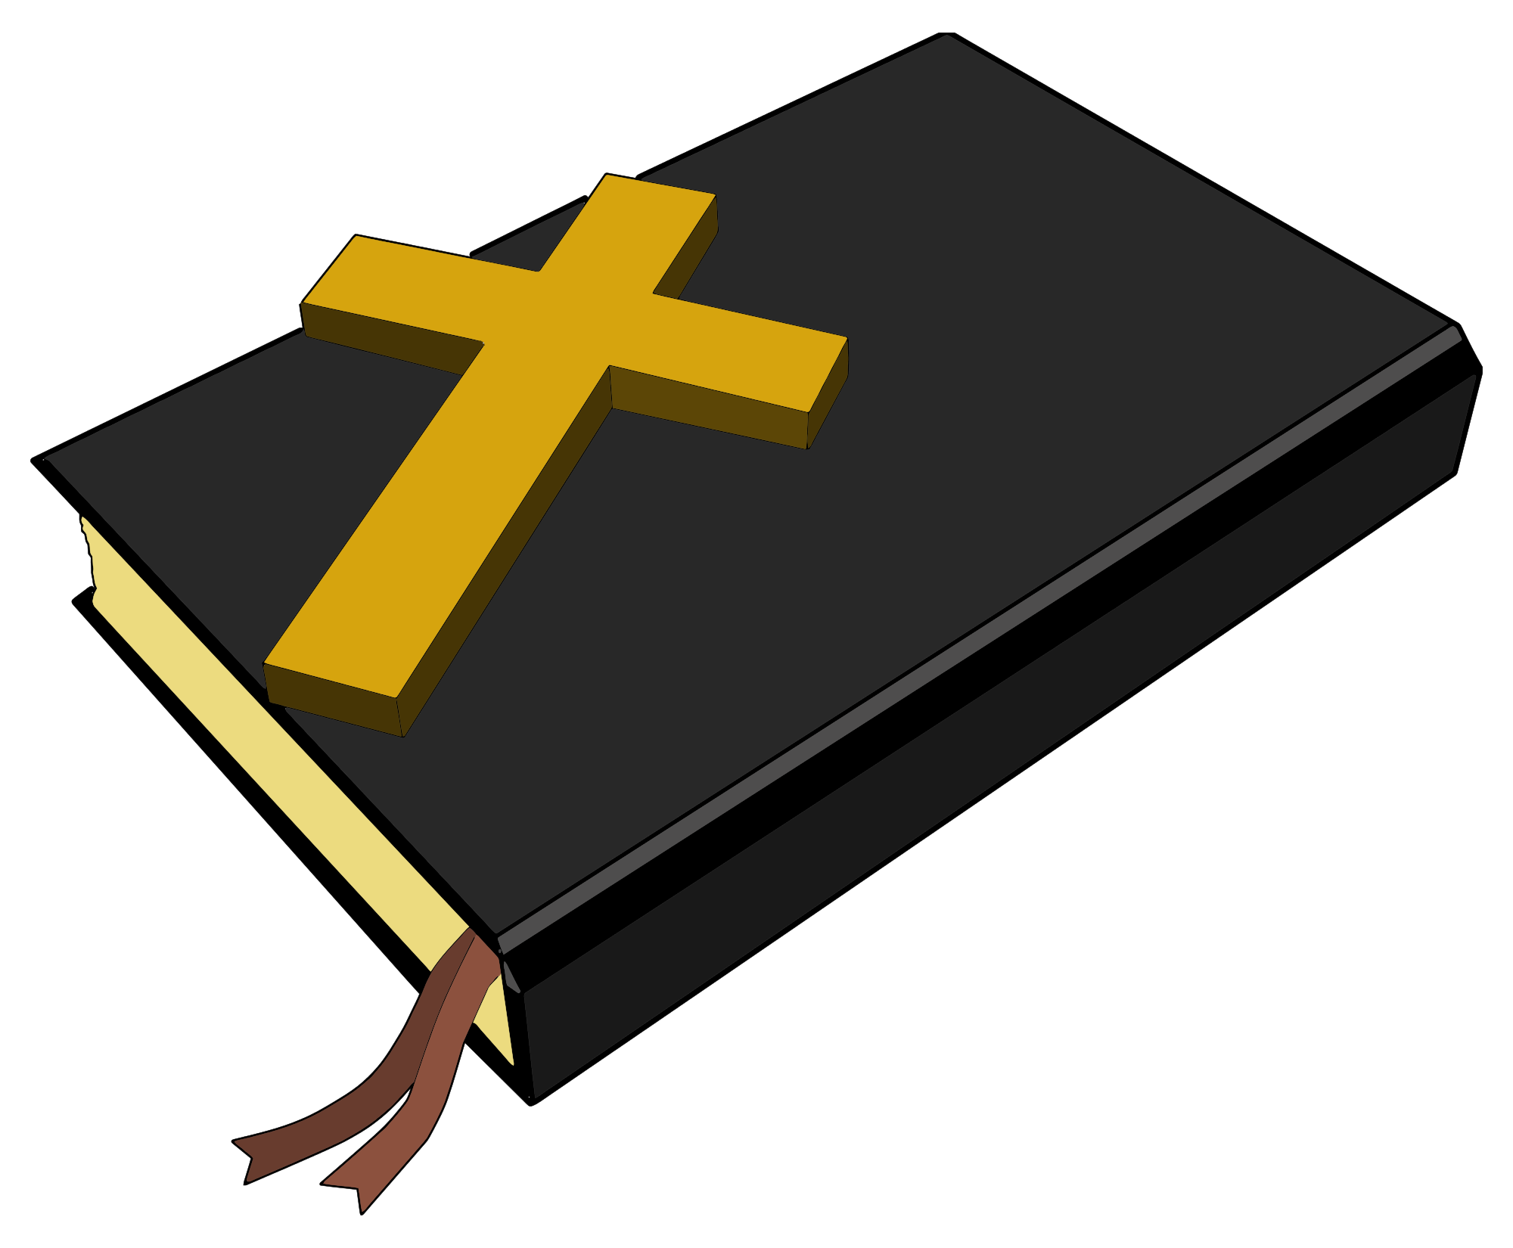  Index: TT = Trinity Tower  KT = King Tower  PT = Providence Tower  CT = Covenant Tower  HT = Hope Tower  PcT = Peace Tower  HeH = Heritage Hall  HaH = Harmony Hall  HoH = Horizon Hall  Italics = CH990  Underline = Towers Nursing Office | Canada Day!  10am Roman Catholic Mass – Harmony Hall  10:30am Peace Tower Coffee Social – Horizon Hall  2pm- Bingo! – Harmony Hall | 9:30am Devotions Ch.990  10am Hope & Trinity Coffee Social – Harmony Hall  11am Fun + Fitness - Heritage Hall  1pm Bridge Club – KT Library  6:30pm Bid Euchre – PT Meeting Room | 9am Busy Hands – Trinity Tower Meeting Room  9:30am Devotions Ch.990  10am – Nordic Pole Walking Lessons- Harmony Hall  Sign-Up  12pm Canada Day BBQ hosted by the Red Tulip – Horizon Hall  1:30pm Cribbage Club – PT Meeting Room  2pm Operation Mercy Yarn Pick up – Harmony Hall | 9:30am Devotions  Ch. 990  1pm Klaverjassen – KT Library  1:30pm Movie Matinee – Heritage Hall  2pm Prayer Shawl Group – CT Lounge  7pm KTEE Euchre – Horizon Hall | 11am Yoga with Kathleen Osmond – Horizon Hall  7pm Board Games Night – Horizon Hall  7pm Bingo! – Harmony Hall | 10am King Tower Coffee Social – Horizon Hall  10am – Providence Tower Coffee Social – PT Meeting Room
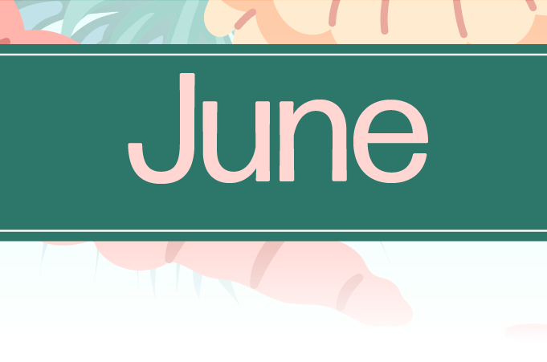
HCH Towers Activities
Sunday | Monday | Tuesday | Wednesday | Thursday | Friday | Saturday
7 | 8 | 9 | 10 | 11 | 12 | 13

Towers Activities Weekly Calendar

10am Church Service- Heritage Hall  4:30pm Nederland’s Zingt – Ch.990  Index: TT = Trinity Tower  KT = King Tower  PT = Providence Tower  CT = Covenant Tower  HT = Hope Tower  PcT = Peace Tower  HeH = Heritage Hall  HaH = Harmony Hall  HoH = Horizon Hall  Italics = CH990  Underline = Towers Nursing Office | 10am Roman Catholic Mass – Harmony Hall  10:30am-2:30pm Cody’s Cows – Outside the Old Faith Manor  10:30am Peace Tower Coffee Social – Horizon Hall  2pm- Bingo! – Harmony Hall | 9:30am Devotions Ch.990  10am Vendor: Red Touch Studios – Across from Front Reception  10am Hope & Trinity Coffee Social – Harmony Hall  1pm Bridge Club – KT Library  6:30pm Bid Euchre – PT Meeting Room  7pm Music on the Patio – New Faith Manor Patio | 8:30am Foot Care Clinic – TNO Nursing Station  9am Busy Hands – Trinity Tower Meeting Room  9:30am Devotions Ch.990  1:30pm Cribbage Club – PT Meeting Room  2pm Operation Mercy Yarn Pick up – Harmony Hall  7pm Travelogue with the Zinkweg’s- Harmony Hall | 9:30am Devotions  Ch. 990  1pm Klaverjassen – KT Library  2pm Prayer Shawl Group – CT Lounge  7pm KTEE Euchre – Horizon Hall | 7pm Board Games Night – Horizon Hall  7pm Bingo! – Harmony Hall | 10am King Tower Coffee Social – Horizon Hall  10am – Providence Tower Coffee Social – PT Meeting Room
HCH Towers Activities
Sunday | Monday | Tuesday | Wednesday | Thursday | Friday | Saturday
14 | 15 | 16 | 17 | 18 | 19 | 20

Towers Activities Weekly Calendar

10am Church Service- Heritage Hall  4:30pm Nederland’s Zingt – Ch.990  Index: TT = Trinity Tower  KT = King Tower  PT = Providence Tower  CT = Covenant Tower  HT = Hope Tower  PcT = Peace Tower  HeH = Heritage Hall  HaH = Harmony Hall  HoH = Horizon Hall  Italics = CH990  Underline = Towers Nursing Office | 10am Roman Catholic Mass – Harmony Hall  10:30am Peace Tower Coffee Social – Horizon Hall  11am Armchair Travels: Egypt Yesterday and Today – Ch. 990  2pm- Bingo! – Harmony Hall | 9:30am Devotions Ch.990  10am Vendor: Solomon’s Clothing – Across from Front Reception  10am Hope & Trinity Coffee Social – Harmony Hall  10am Music & Movement – Horizon Hall  1pm Bridge Club – KT Library  6:30pm Bid Euchre – PT Meeting Room | 9am Busy Hands – Trinity Tower Meeting Room  9:30am Devotions Ch.990  10am – Nordic Pole Walking Lessons- Harmony Hall  (Community Walk-Meet at chess board by front reception)  1pm Mobility Clinic- TNO Nursing Station  1:30pm Cribbage Club – PT Meeting Room  2pm Operation Mercy Yarn Pick up – Harmony Hall | 9:30am Devotions  Ch. 990  1pm Klaverjassen – KT Library  2pm Prayer Shawl Group – CT Lounge  7pm KTEE Euchre – Horizon Hall  7pm Movie Night – Heritage Hall | 11am Yoga with Kathleen Osmond – Horizon Hall  7pm Board Games Night – Horizon Hall  7pm Bingo! – Harmony Hall | 10am King Tower Coffee Social – Horizon Hall  10am – Providence Tower Coffee Social – PT Meeting Room
HCH Towers Activities
Sunday | Monday | Tuesday | Wednesday | Thursday | Friday | Saturday
21 | 22 | 23 | 24 | 25 | 26 | 27

Towers Activities Weekly Calendar

10am Church Service- Heritage Hall  4:30pm Nederland’s Zingt – Ch.990  Index: TT = Trinity Tower  KT = King Tower  PT = Providence Tower  CT = Covenant Tower  HT = Hope Tower  PcT = Peace Tower  HeH = Heritage Hall  HaH = Harmony Hall  HoH = Horizon Hall  Italics = CH990  Underline = Towers Nursing Office | 10am Roman Catholic Mass – Harmony Hall  10:30am Peace Tower Coffee Social – Horizon Hall  2pm- Bingo! – Harmony Hall | 9:30am Devotions Ch.990  10am Traditions Alive – Across from Front Reception  10am Hope & Trinity Coffee Social – Harmony Hall  1pm Bridge Club – KT Library  6:30pm Bid Euchre – PT Meeting Room  7pm Music on the Patio – New Faith Manor Patio | 8:30am Foot Care Clinic – TNO Nursing Station  9am Busy Hands – Trinity Tower Meeting Room  9:30am Devotions Ch.990  Sign Up  12pm- Tenant BBQ- Harmony Hall  1:30pm Cribbage Club – PT Meeting Room  2pm Operation Mercy Yarn Pick up – Harmony Hall | 9:30am Devotions  Ch. 990  1pm Klaverjassen – KT Library  2pm Prayer Shawl Group – CT Lounge  7pm KTEE Euchre – Horizon Hall | 11am Yoga with Kathleen Osmond – Horizon Hall  1:30pm Karaoke – Harmony Hall  7pm Board Games Night – Horizon Hall  7pm Bingo! – Harmony Hall | 10am King Tower Coffee Social – Horizon Hall  10am – Providence Tower Coffee Social – PT Meeting Room
HCH Towers Activities.
Towers Activities Weekly Calendar

Sunday | Monday | Tuesday | Wednesday | Thursday | Friday | Saturday
28 | 29 | 30 | 31 | 1 | 2 | 3

10am Church Service- Heritage Hall  4:30pm Nederland’s Zingt – Ch.990  Index: TT = Trinity Tower  KT = King Tower  PT = Providence Tower  CT = Covenant Tower  HT = Hope Tower  PcT = Peace Tower  HeH = Heritage Hall  HaH = Harmony Hall  HoH = Horizon Hall  Italics = CH990  Underline = Towers Nursing Office | 10am Roman Catholic Mass – Harmony Hall  10:30am Peace Tower Coffee Social – Horizon Hall  11am Disney Nature “Earth” Documentary – Ch. 990  2pm- Bingo! – Harmony Hall | 9:30am Devotions Ch.990  10am Epicure – Across from Front Reception  10am Hope & Trinity Coffee Social – Harmony Hall  10am Music & Movement – Horizon Hall  1pm Bridge Club – KT Library  6:30pm Bid Euchre – PT Meeting Room | 9am Busy Hands – Trinity Tower Meeting Room  9:30am Devotions Ch.990  10am – Nordic Pole Walking Lessons- Harmony Hall  1:30pm Cribbage Club – PT Meeting Room  2pm Operation Mercy Yarn Pick up – Harmony Hall  2pm Birthday Party – Heritage Hall  Performance: Heather Christine | 9:30am Devotions  Ch. 990  1pm Klaverjassen – KT Library  1:30pm Movie Matinee – Heritage Hall  2pm Prayer Shawl Group – CT Lounge  7pm KTEE Euchre – Horizon Hall | 11am Yoga with Kathleen Osmond – Horizon Hall  7pm Board Games Night – Horizon Hall  7pm Bingo! – Harmony Hall | 10am King Tower Coffee Social – Horizon Hall  10am – Providence Tower Coffee Social – PT Meeting Room
HCH Towers Activities.

